

Supplier Packaging Requirements

Supplier Packaging Table of Contents

- Introduction
- General Requirements
- Packaging Requirements
- Palletization
- Shipping Documents
6. Shipping Labels

1.0 Introduction

Purpose

To define and identify Weil-McLain’s packaging and labeling requirements to suppliers.

Scope

This manual applies to all Weil-McLain suppliers shipping production parts.

Responsibilities

Suppliers are responsible to design all packaging unless otherwise designed by Weil-McLain Product Engineering department. Suppliers must submit packaging proposals to Weil-McLain for approval.

Suppliers are required to comply with the standards identified in this manual.

2.0 General Requirements

Suppliers are responsible for designing packaging and assuring packaging is capable to adequately protect product and ensure product during normal transportation and handling methods. Product must arrive free from damage and contamination. If Weil-McLain Product Engineering designs packaging, suppliers must follow the specification.

Packaging must be approved prior to the first shipment of production material. Suppliers must use the Weil-McLain Packaging Proposal form detailing their method of packaging. The Packaging Proposal form must be submitted with First Article documentation. Changes to packaging, quantity, or materials require a resubmittal for approval.

A test shipment may be required to determine the effectiveness of designed packaging. This test shipment must be made prior to First Article Approval.

A standard packaging quantity and container size must be established and adhered to for all product shipped. Suppliers shall not deviate from this standard box quantity without permission from Weil-McLain Purchasing.

Use of recyclable materials is encouraged when possible and cost effective. Use of salvaged pallets is prohibited.

Packaging must be designed to assure ease of handling and part removal.

Only Weil-McLain approved carriers should be used for shipping product. Contact your Weil-McLain buyer for a list of approved carriers.

Packaging Authorization Flow Chart

Suppliers retrieve packaging specifications from Weil-McLain website

Suppliers submit Packaging Proposal form

Packaging proposal form is evaluated

Accepted?
No

Yes

Trial requested by Weil-McLain?
Yes
Supplier submits trial shipment

NO

Accepted?
No

Yes

Supplier notified of authorization to ship in designated packaging

3.0 Packaging Requirements

Container Requirements

Container Types: Suppliers must use either corrugated or returnable containers. Use of other container types is prohibited without prior approval. Use of returnable containers requires Weil-McLain approval.

Expendable Containers:

Double or tripled walled containers are preferred
- Containers should have certificate stamp that indicates Edge Crush Test or Burst Strength. Desired min. requirement is 44 ECT or 275 lb burst strength
- Containers must withstand and protect product during double stacking of pallets
- Containers shall not be sealed with metallic staples
- Container weight shall not exceed 60 lbs.
- Contents of package should fill container as much as possible to limit amount of void
- Stacking exceptions must be noted on the pallet load such as “Do Not Double Stack” etc…

Containers must be adequately sealed to assure they do not open during transit or normal handling. Acceptable sealing methods include tape (plastic film or paper tape) or glue.

Pallet Requirements

All pallets shall be constructed of wood unless approved by Weil-McLain. Pallets must have minimum strength to withstand normal material handling and distribution. All pallets must be in excellent condition. Salvage pallets are prohibited. Pallets must have strength to support the stacked load.

All pallets must have 4-way entry.

Pallets received from overseas shall be made from treated wood and free from pests.

Acceptable Pallet Dimensions:
48” x 45” x 5”
36” X 30” x 5”
32” X 30” x 5”

Note: Suppliers must design a pallet to accommodate a part whose size exceeds the acceptable pallet footprint.

Pallets shall not exceed a maximum height of 50” with a stacked load. Maximum Height includes pallet. This is to ensure maximum space utilization inside trailer or sea container.

A fully loaded pallet must be less than 2000 lbs.

Container / Load Securement

All pallets shall have its load banded with plastic (polyester) strapping. Use of metallic strapping is prohibited due to safety hazards, with the exception of banding castings and sheet metal. A minimum of 2 vertical straps lengthwise and 2 vertical straps widthwise must be applied to secure the load to the pallet.

Stretch wrapping should be used to prevent shifting of the load during transit. Stretch wrapping shall not be used as an only means to secure a load. A minimum of three layers is required for application. The stretch wrap must be secured to 3” below the deck boards of the pallet. Stretch wrap must be clear enough to allow scanning of label bar codes.

Corner-boards should be used as necessary or required to provide additional protection

Special Packaging

Airfreight and other special shipments may require reinforced packaging protection due to potentially rougher handling.

4.0 Palletization

Containers must be palletized when shipping more than 5 containers in a shipment.

Suppliers should load only one part number per pallet unless shipping via express delivery service (ex. UPS).

Part numbers shall not be on more than one pallet when the quantity supplied is sufficient to make a full pallet load.

Containers must be oriented to fully utilize the length and width of the pallet. To ensure vertical strength of containers, containers must not overhang side of the pallet.

Brick stacking and pyramid stacking are prohibited. Partial loads should be shipped with the void in the middle of the pallet.

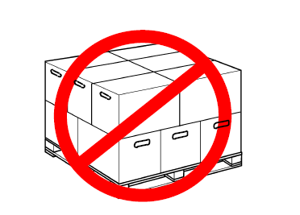
Brick Stacking
Pyramid Stacking

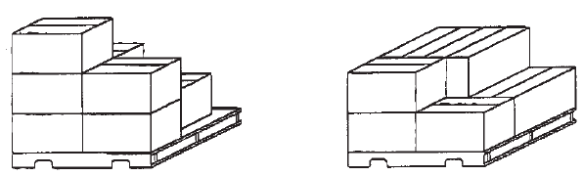

Acceptable Stacking

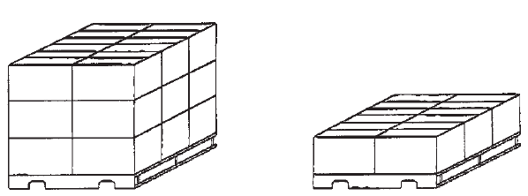

Mixed Loads

Mixed loads should be used only when shipped quantities prevent full pallet loads for a single part #.

A “Mixed Load” label must be applied to each skid containing a mixed load.

Similar part numbers must be grouped together to allow for ease of identification.

When shipping mixed loads heavier containers must not be placed on top of lighter weight containers. The weight of the load must be balanced on the pallet while keeping similar parts together.

If the top layer of the load is unleveled a “DO NOT STACK” label shall be posted on all 4 sides of the load.

5. 0 Shipping Documents

Suppliers must supply a packing slip and Bill of Lading for each shipment of product to Weil-McLain. The packing slips must include at minimum the following information:

- Packing Slips
- Supplier name
- Supplier address
- Phone and fax numbers
- Product ship date
- Weil-McLain purchase order number
- Weil-McLain purchase order line number for product shipped
- Weil-McLain part number
- Weil-McLain part description
- Quantity Shipped
- Quantity listed on the packing slip must be in the same unit of measure as the quantity on the purchase order.

Any product with packing slips missing any information will be quarantined until Purchasing contact the supplier to a get a corrected packing slip.

There will be a $200 handling fee for each incidence of noncompliance to packing slip requirements.

Shipping Label Requirement

TBD

